**LIBRARY MANAGEMENT SYSTEM**

**-NIKITA ANANDMANI**

**(22BBS0202)**

**ABOUT THE PROJECT:**

The Library Management System is a platform where librarians can maintain a database of books, add new books, search for a particular book, delete a book, and see all the books in the library. It is a useful platform as they do not need to use a manual and enter the name and details of the book every time and there is low risk of it getting stolen.

**SCREENSHOTS OF A WORKING MODEL:**

**LANDING PAGE(LOGIN):**

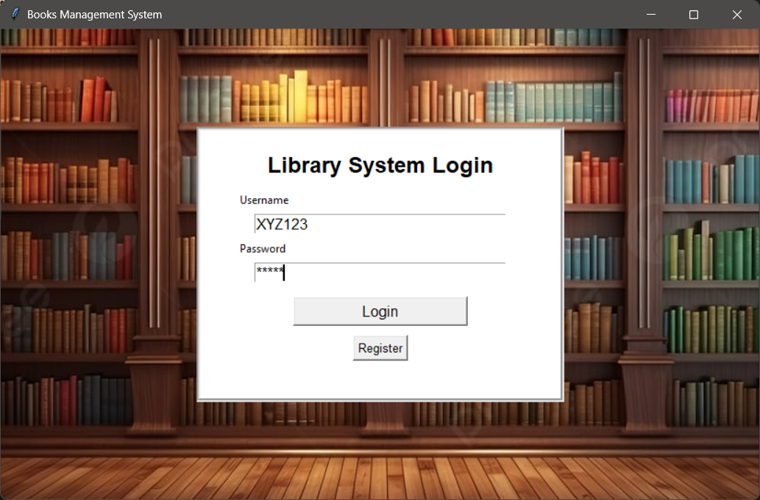

Note: the username password is already in the database.

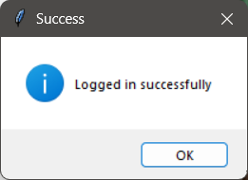

**REGISTER PAGE:**

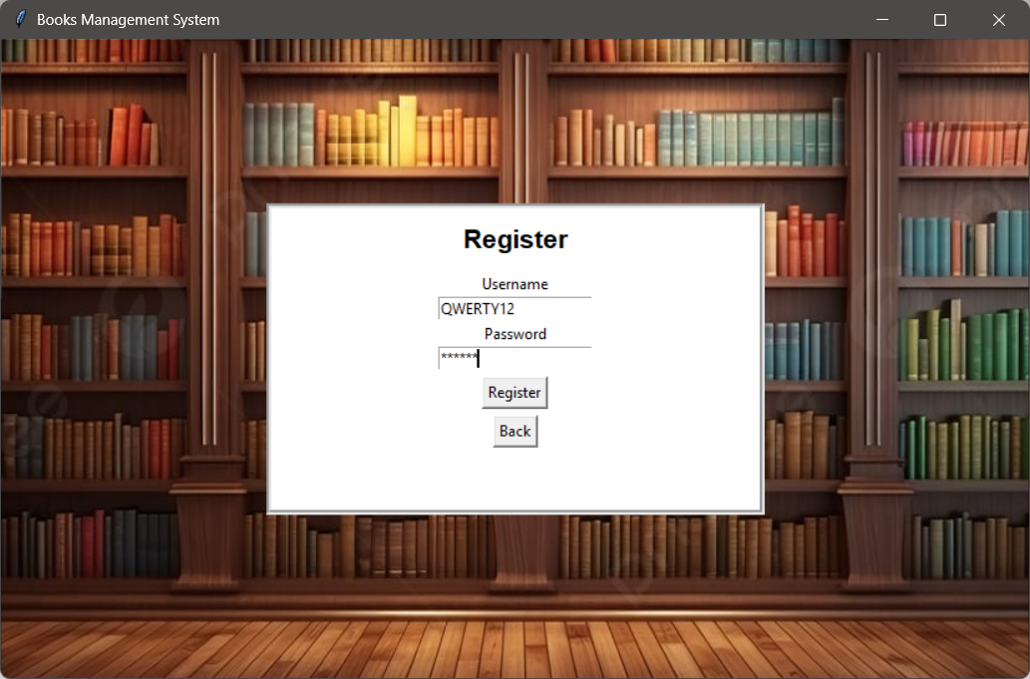

**SUCCESSFULLY REGISTERED:**

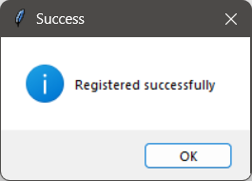

**DASHBOARD:**

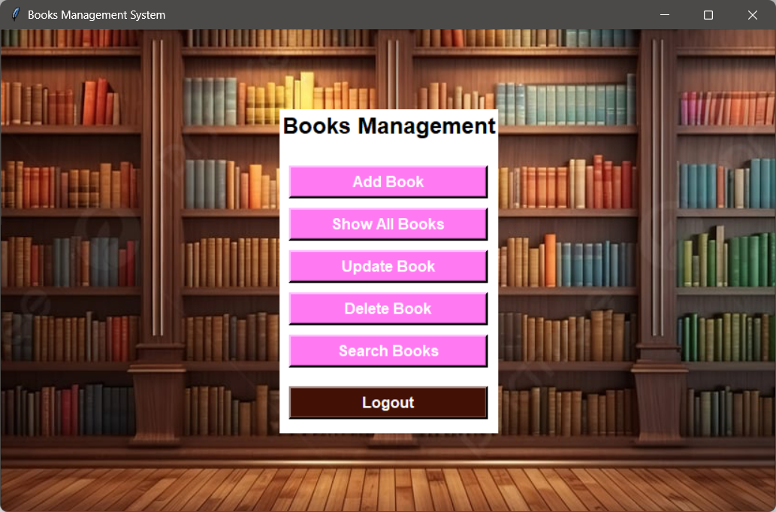

**ADD BOOK PAGE:**

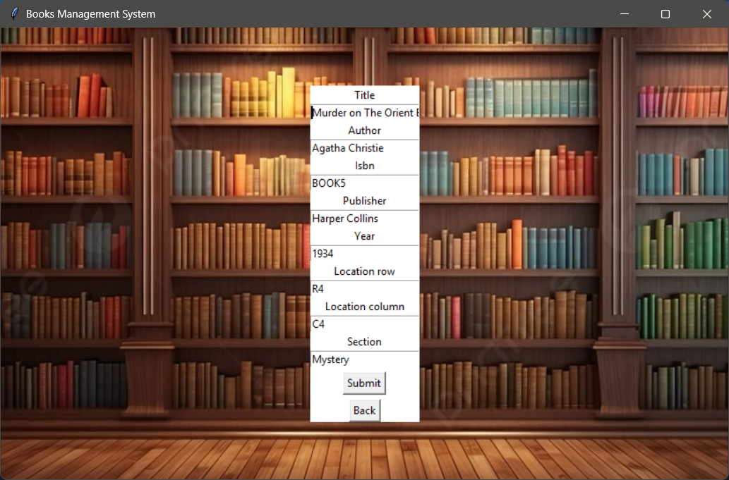

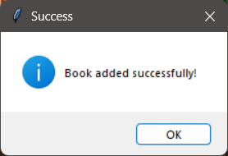

**SHOW ALL BOOKS PAGE:**

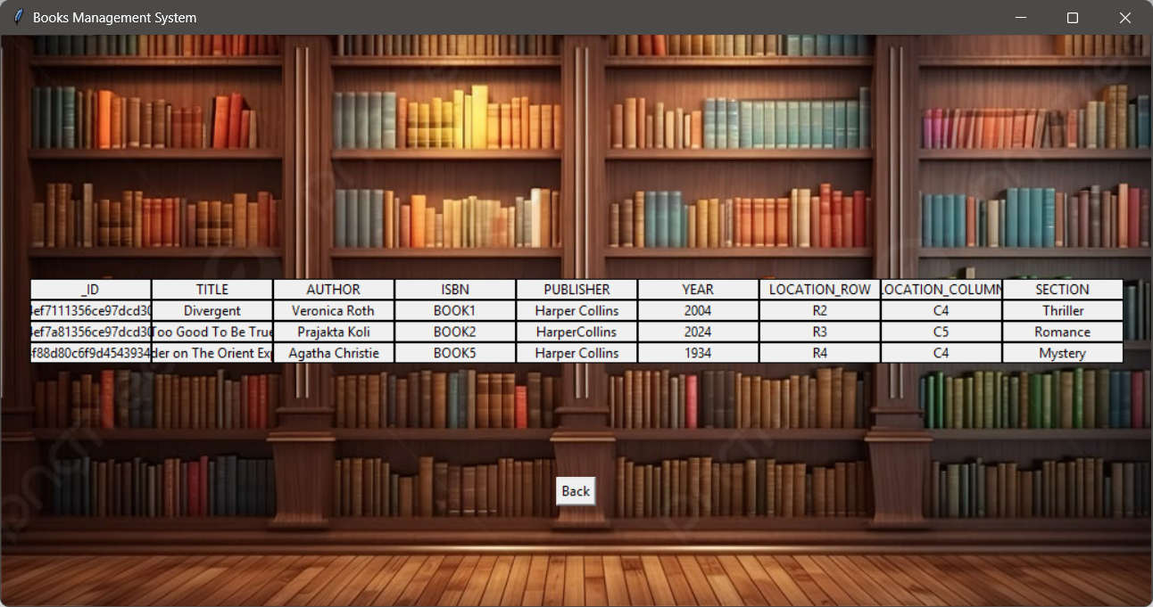

**UPDATE BOOKS SECTION:**

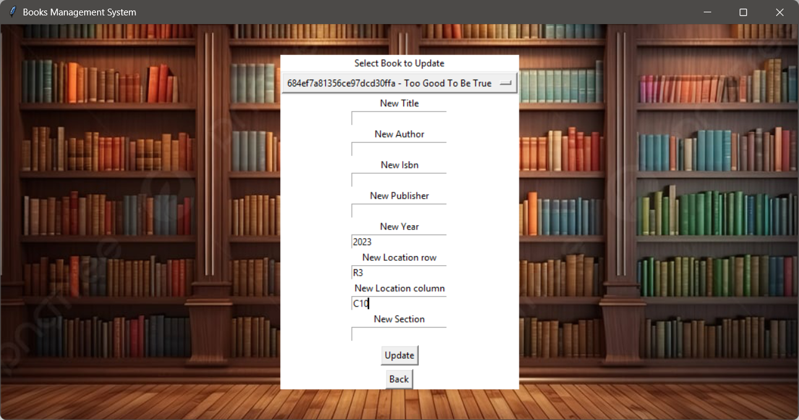

**UPDATED SUCCESSFULLY:**

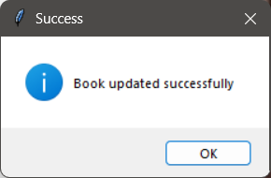

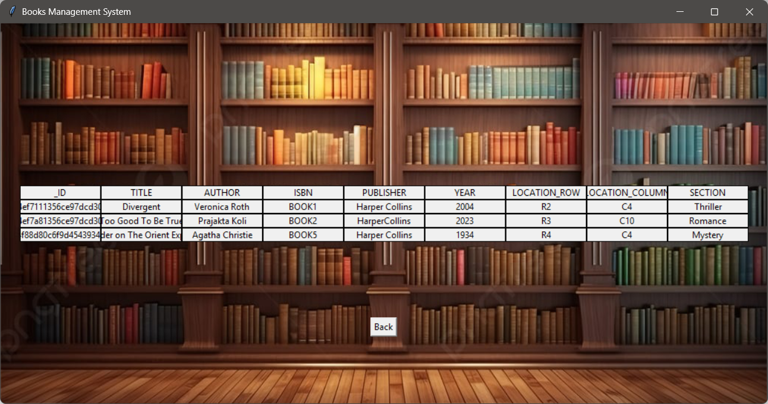

**DELETE BOOK PAGE:**

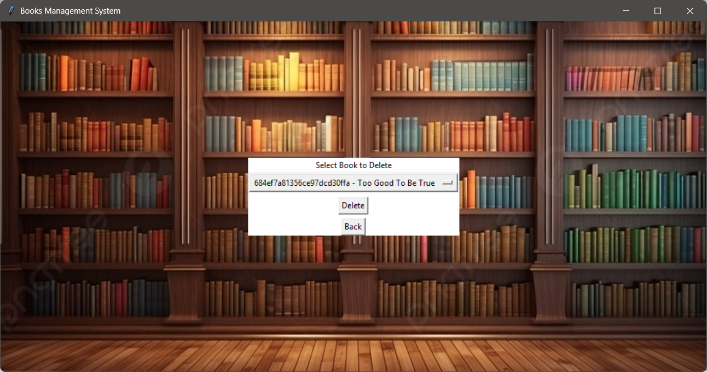

**DELETED SUCCESSFULLY:**

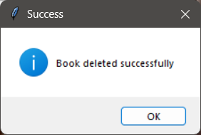

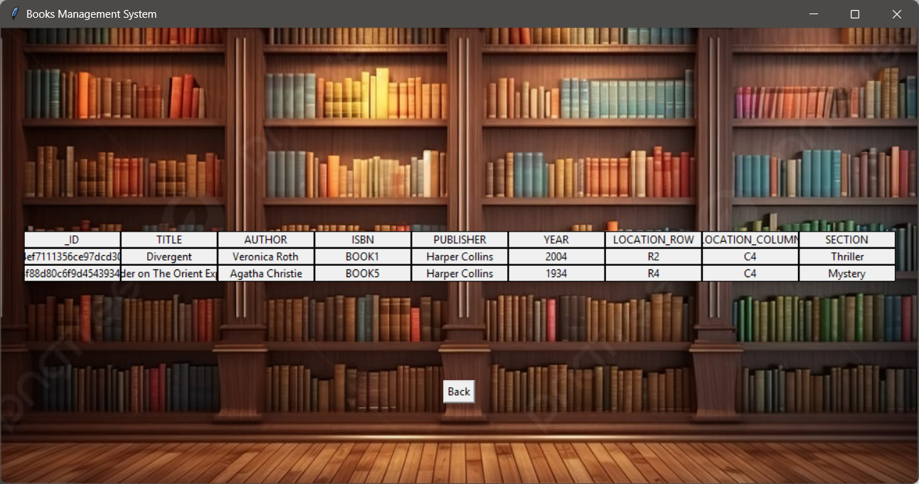

**SEARCH FOR BOOKS PAGE:**

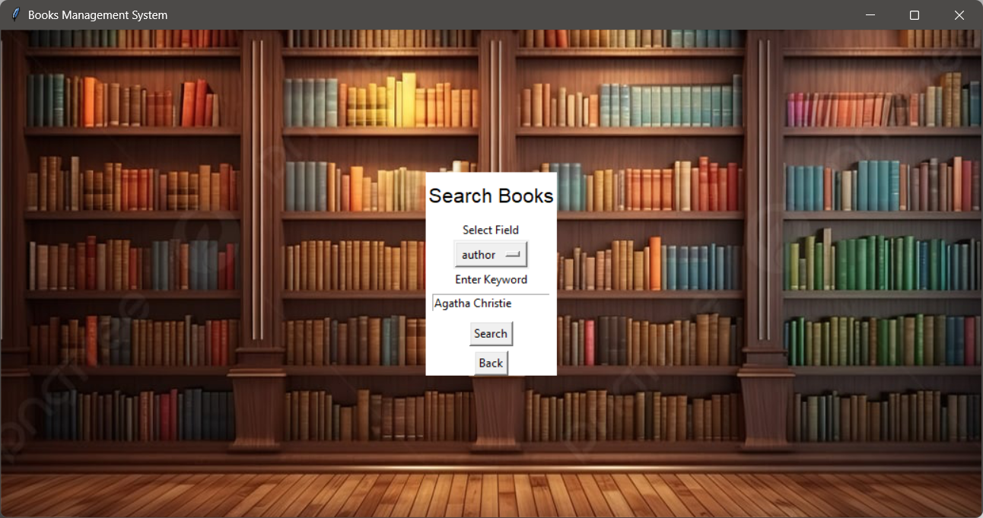

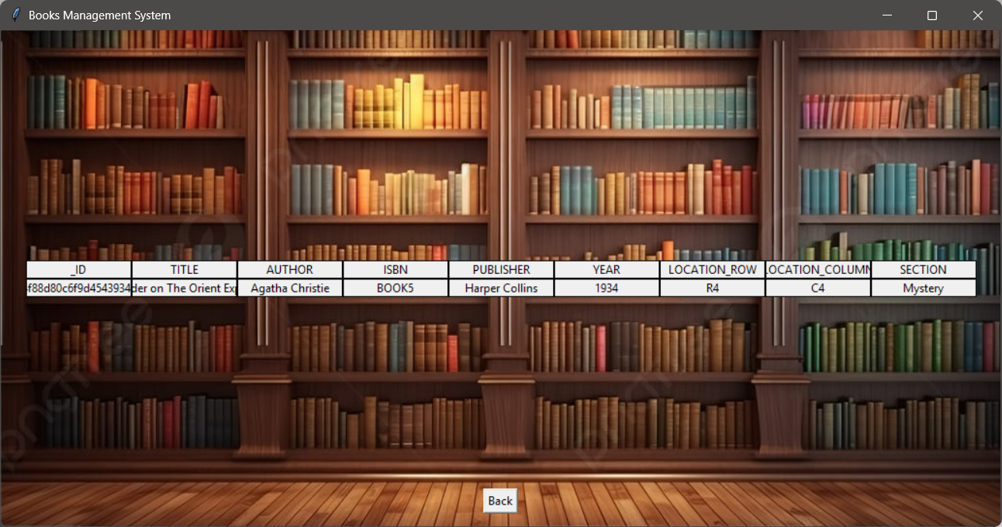

After clicking on log out, the user has to login again to use the platform.

**MONGODB DATABASE SCREENSHOTS:**

Users database for authentication:

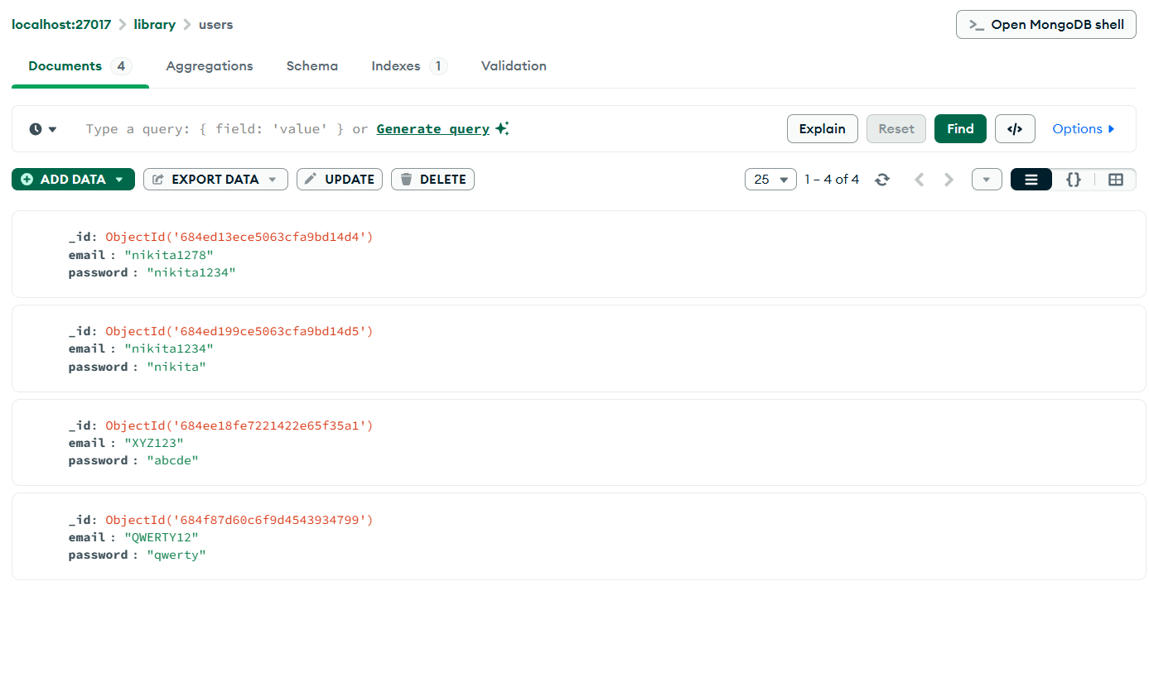

Library Database of books:

